**COMSATS University Islamabad,**

**Abbottabad Campus**

**SOFTWARE REQUIREMENTS SPECIFICATION   
(SRS DOCUMENT)**

**for**

**An ERP System**  
Version 1.0

***By***

**Abdullah Khan CIIT/SP20-BSE-042/ATD**

**Syed Muhammad Saqib CIIT/SP20-BSE-050/ATD**

**Shameer Mukhtar CIIT/SP20-BSE-076/ATD**

***Supervisor*Dr. Kashif Nasr**

***Bachelor of Science in Computer Science (2020-2024)***

**Table of Contents**

**Revision History 3**

**1.** **Introduction 5**

1.1 Purpose 5

1.2 Scope 5

**2.** **Overall description 5**

2.1 Product perspective 5

2.2 Operating environment 5

2.3 Design and implementation constraints 5

**3.** **Requirement identifying technique 6**

3.1 Use Case Diagram 6

3.2 Use Case Description 6

**4.** **Specific Requirements 8**

4.1 System features 8

**5.** **Quality attributes**

5.1 Usability 9

5.2 Performance 9

**6.** **External interface requirements 35**

6.1 User interfaces 35

6.2 Software interfaces 35

6.3 Hardware interfaces 35

6.4 Communications interfaces 35

**7.** **Project Gantt chart 35**

**8.** **References 36**

**Revision History**

|  |  |  |  |
| --- | --- | --- | --- |
| **Name** | **Date** | **Reason for changes** | **Version** |
|  |  |  |  |
|  |  |  |  |

**Application Evaluation History**

|  |  |
| --- | --- |
| **Comments (by committee)**  **\*include the ones given at scope time both in doc and presentation** | **Action Taken** |
|  |  |
|  |  |

**Supervised by**

**Dr. Kashif Nasr**

Signature______________

**Introduction**

The purpose of this Software Requirements Specification (SRS) document is to provide a comprehensive overview and detailed specifications of the ERP (Enterprise Resource Planning) System.

This document serves as a guideline for the development team, stakeholders, and users involved in the project. It outlines the functional and non-functional requirements of the ERP System, including its scope, objectives, and constraints.

The SRS document aims to facilitate a clear understanding of the system's features, behavior, and interfaces, ensuring that all parties involved have a common understanding of the system's functionalities and deliverables.

**Purpose**

The purpose of this ERP System is to cater to the specific needs of suppliers by developing an ERP system tailored to their requirements. Unlike existing ERP systems designed for large-scale organizations, this system aims to streamline processes specifically for suppliers.

The project's objective is to provide suppliers with a comprehensive and user-friendly solution that addresses their unique challenges and enables them to make informed decisions.

**Scope**

The software being developed is a web-based supplier-focused ERP system that aims to streamline business processes such as inventory management, customer relationship management (CRM), human resource management (HRM), and financial management.

The ERP system is designed specifically for suppliers to enhance operational efficiency, improve decision-making capabilities, and provide a comprehensive solution for managing various aspects of their daily operations.

**Overall description**

**Product perspective**

This ERP system addresses the challenge faced by numerous suppliers who rely on manual record-keeping and management processes.

This ERP system is specifically tailored to meet the needs of small-scale suppliers, filling a gap in the market where most existing ERP systems are primarily designed for larger organizations. By implementing this system, small-scale suppliers can effectively streamline their daily processes, improving operational efficiency and enabling better management of their business operations.

The scope of this ERP system encompasses various business processes, such as inventory management, financial accounting, human resources, and customer relationship management. It aims to streamline operations, enhance efficiency, and improve decision-making capabilities.

**Operating environment**

OE-1: The system shall operate correctly with the following web browsers: Windows Internet Explorer, Firefox, Google Chrome, and Apple Safari.

OE-2: The ERP system shall be accessible on various devices, including personal computers (PCs), mobile devices (such as smartphones), and tablets.

OE-3: The ERP system shall be designed to support global accessibility, allowing users from different geographical locations to access and utilize the application.

**Design and implementation constraints**

CO-1: The system shall utilize the MERN stack, consisting of MongoDB as the database, Express.js as the web application framework, React.js for the frontend user interface, and Node.js as the server-side runtime environment.

CO-2: The system shall leverage the capabilities of MongoDB, a NoSQL database, for efficient and scalable data storage, retrieval, and management.

CO-3: The system shall utilize Express.js as the web application framework for handling routing, middleware, and server-side logic implementation.

**Requirement Identifying Technique**

**Use case diagram**

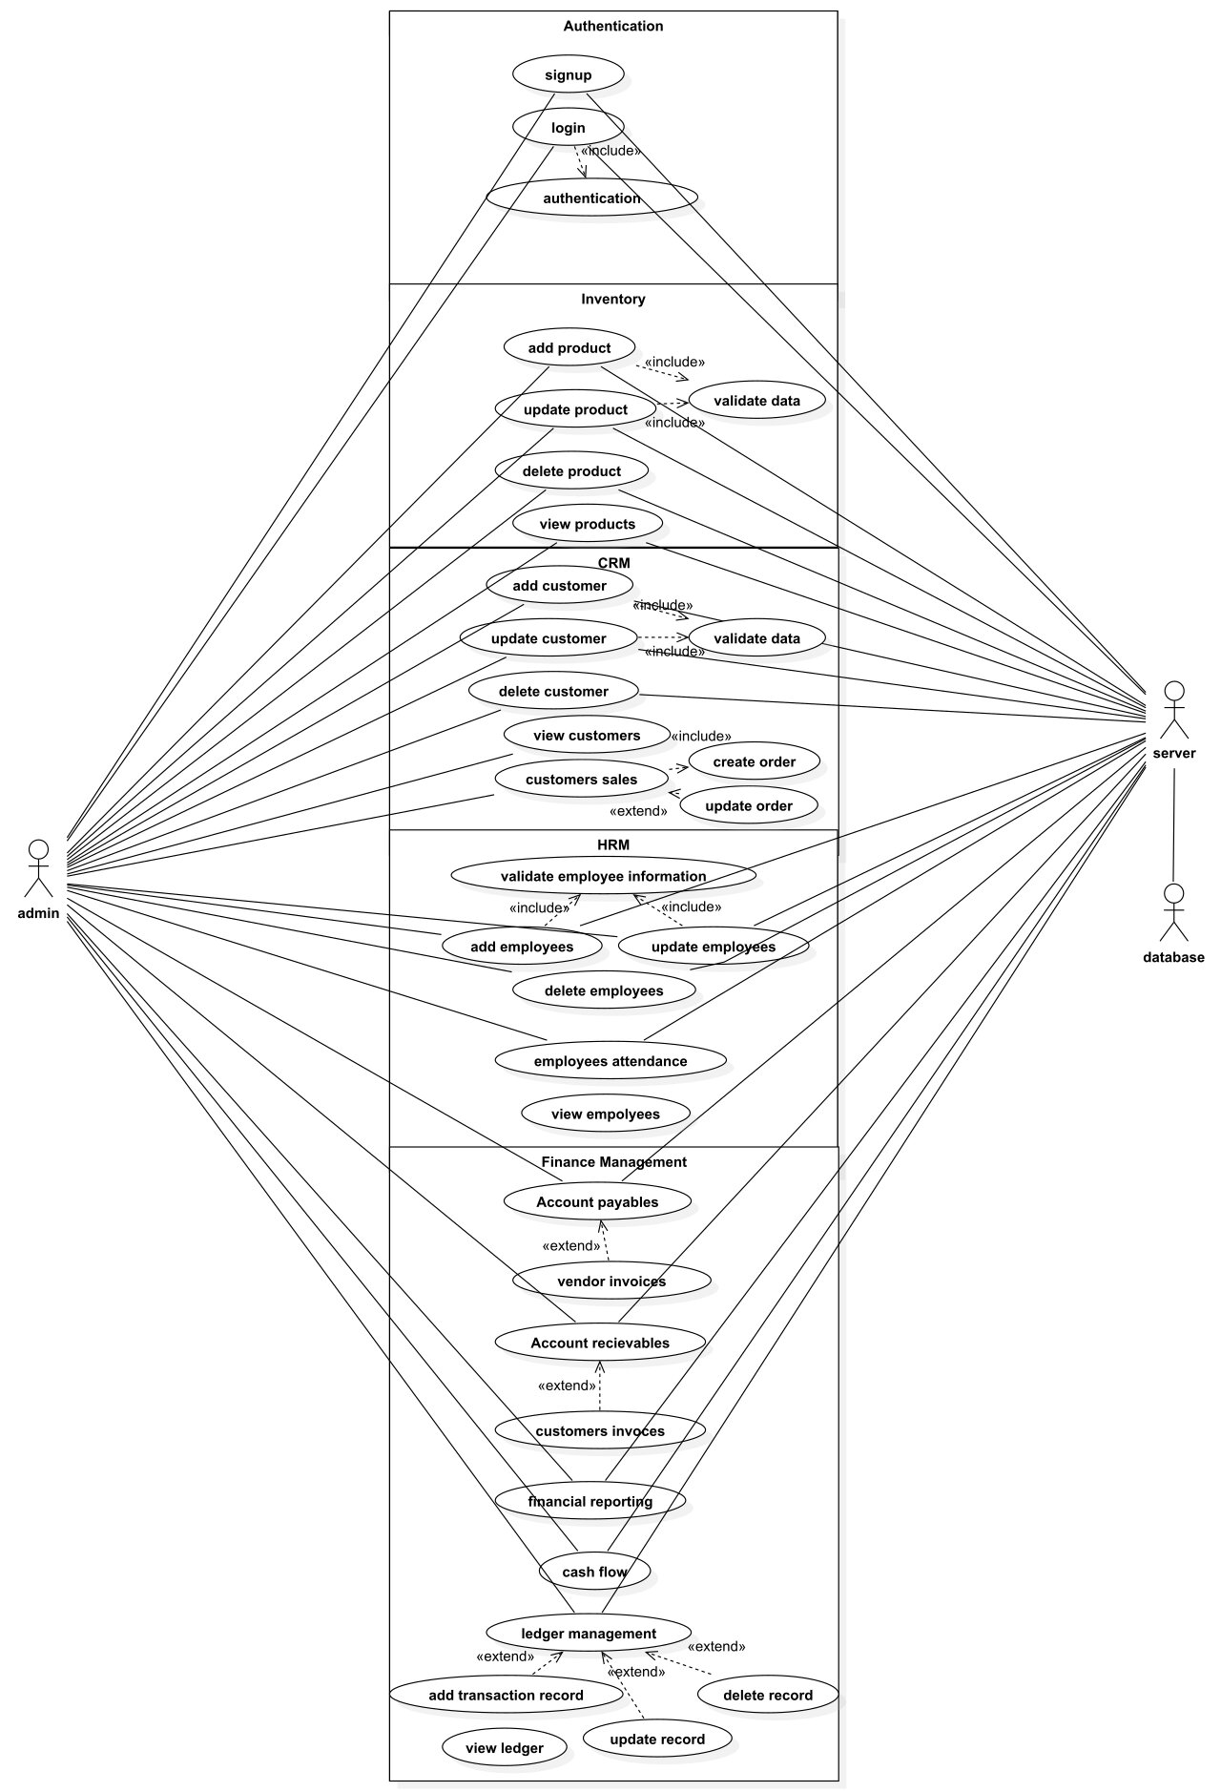

**Use case description**

**Use Case 1: Ledger Management**

|  |  |
| --- | --- |
| Identifier | UC-1 |
| Use Case Name | Ledger Management |
| Actors | Primary Actor: User |
| Description | This use case allows the user to manage ledger transactions by adding, updating, and deleting transaction records. |
| Trigger | The user indicates the need to manage ledger transactions. |
| Preconditions | The user is authenticated and has access to the ledger management functionality. |
| Postconditions | The ledger transaction records are updated according to the user's actions. |
| Normal Flow | 1. The user selects the option to add a transaction record.  2. The user enters the transaction details.  3. The system validates the transaction data.  4. The system saves the transaction record.  5. The user selects the option to update a transaction record.  6. The user selects the transaction to be updated.  7. The user modifies the transaction details.  8. The system validates the updated transaction data.  9. The system saves the updated transaction record.  10. The user selects the option to delete a transaction record.  11. The user selects the transaction to be deleted.  12. The system prompts for confirmation.  13. The system deletes the selected transaction record. |
| Alternative Flows | None |
| Exceptions | None |
| Business Rules | None |

**Use Case 2: Accounts Payable**

|  |  |
| --- | --- |
| Identifier | UC-2 |
| Use Case Name | Accounts Payable |
| Actors | Primary Actor: User |
| Description | The User can manage accounts payable by creating, tracking, and processing payments to vendors. |
| Trigger | The User indicates the need to manage accounts payable. |
| Preconditions | PRE-1: The User is logged into the ERP system. |
| Postconditions | POST-1: The payment to the vendor is processed and recorded. |
| Normal Flow | 1. The User selects the option to create a new accounts payable entry.  2. The User provides the necessary details for the payment, including vendor information, invoice details, and payment amount.  3. The system validates the payment details.  4. The system records the accounts payable entry.  5. The User selects the option to track accounts payable.  6. The system displays a list of outstanding payments to vendors.  7. The User selects a specific accounts payable entry to process the payment.  8. The User verifies the payment details and initiates the payment process.  9. The system processes the payment and updates the accounts payable status. |
| Alternative Flows | None |
| Exceptions | None |
| Business Rules | BR-1: All invoices must include a valid company ID and invoice number. |
| Assumptions | None |

**Use Case 3: Accounts Receivable**

|  |  |
| --- | --- |
| Identifier | UC-3 |
| Use Case Name | Accounts Receivable |
| Actors | Primary Actor: User |
| Description | The User can manage accounts receivable by creating, tracking, and processing customer payments. |
| Trigger | The User indicates the need to manage accounts receivable. |
| Preconditions | PRE-1: The User is logged into the ERP system. |
| Postconditions | POST-1: The customer payment is processed and recorded. |
| Normal Flow | 1. The User selects the option to create a new accounts receivable entry.  2. The User provides the necessary details for the payment, including customer information, invoice details, and payment amount.  3. The system validates the payment details.  4. The system records the accounts receivable entry.  5. The User selects the option to track accounts receivable.  6. The system displays a list of outstanding customer payments.  7. The User selects a specific accounts receivable entry to process the payment.  8. The User verifies the payment details and completes the payment process.  9. The system processes the customer payment and updates the accounts receivable status. |
| Alternative Flows | None |
| Exceptions | None |
| Business Rules | BR-1: All customer invoices must include a valid customer ID and invoice number. |
| Assumptions | None |

**Use Case 4: Vendor Invoices**

|  |  |
| --- | --- |
| Identifier | UC-4 |
| Use Case Name | Vendor Invoices |
| Actors | Primary Actor: User |
| Description | The User can manage vendor invoices by recording, reviewing, and processing invoices from vendors. |
| Trigger | The User indicates the need to manage vendor invoices. |
| Preconditions | PRE-1: The User is logged into the ERP system. |
| Postconditions | POST-1: The vendor invoice is recorded and processed. |
| Normal Flow | 1. The User selects the option to record a new vendor invoice.  2. The User provides the necessary details for the invoice, including vendor information, invoice number, and invoice amount.  3. The system validates the invoice details.  4. The system records the vendor invoice.  5. The User selects the option to review vendor invoices.  6. The system displays a list of recorded vendor invoices.  7. The User selects a specific vendor invoice to process.  8. The User reviews the invoice details and initiates the payment process.  9. The system processes the payment and updates the vendor invoice status. |
| Alternative Flows | None |
| Exceptions | None |
| Business Rules | BR-1: Vendor invoices should be accurately recorded in the system to maintain financial records. |
| Assumptions | None |

**Use Case 5: Customer Invoices**

|  |  |
| --- | --- |
| Identifier | UC-5 |
| Use Case Name | Customer Invoices |
| Actors | Primary Actor: User |
| Description | The User can manage customer invoices by creating, reviewing, and processing invoices for customers. |
| Trigger | The User indicates the need to manage customer invoices. |
| Preconditions | PRE-1: The User is logged into the ERP system. |
| Postconditions | POST-1: The customer invoice is recorded and processed. |
| Normal Flow | 1. The User selects the option to create a new customer invoice.  2. The User provides the necessary details for the invoice, including customer information, invoice number, and invoice amount.  3. The system validates the invoice details.  4. The system records the customer invoice.  5. The User selects the option to review customer invoices.  6. The system displays a list of recorded customer invoices.  7. The User selects a specific customer invoice to process.  8. The User reviews the invoice details and completes the payment process.  9. The system processes the payment and updates the customer invoice status. |
| Alternative Flows | None |
| Exceptions | None |
| Business Rules | BR-1: Customer invoices should be recorded and tracked to ensure timely payment and accurate financial reporting. |
| Assumptions | None |

**Use Case 6: Financial Reporting**

|  |  |
| --- | --- |
| Identifier | UC-6 |
| Use Case Name | Financial Reporting |
| Actors | Primary Actor: User |
| Description | The User can generate financial reports to analyze and present financial data within the ERP system. |
| Trigger | The User indicates the need to generate financial reports. |
| Preconditions | PRE-1: The User is logged into the ERP system. |
| Postconditions | POST-1: The financial report is generated and displayed. |
| Normal Flow | 1. The User selects the option to generate a financial report.  2. The User specifies the report parameters, such as the time period, financial categories, and desired format.  3. The system retrieves the relevant financial data based on the specified parameters.  4. The system performs calculations and generates the financial report.  5. The system displays the financial report to the User. |
| Alternative Flows | None |
| Exceptions | None |
| Business Rules | None |
| Assumptions | None |

**Use Case 7: Cash Flow**

|  |  |
| --- | --- |
| Identifier | UC-7 |
| Use Case Name | Cash Flow |
| Actors | Primary Actor: User |
| Description | The User can manage cash flow by tracking and analyzing the movement of funds within the ERP system. |
| Trigger | The User indicates the need to manage cash flow. |
| Preconditions | PRE-1: The User is logged into the ERP system. |
| Postconditions | POST-1: The cash flow information is updated and displayed. |
| Normal Flow | 1. The User selects the option to view cash flow.  2. The system retrieves the current cash flow information.  3. The system displays the cash flow information to the User. |
| Alternative Flows | None |
| Exceptions | None |
| Business Rules | None |
| Assumptions | None |

**Use Case 8: Add Customer**

|  |  |
| --- | --- |
| Identifier | UC-8 |
| Use Case Name | Add Customer |
| Actors | Primary Actor: User |
| Description | The User can add a new customer to the CRM system. |
| Trigger | The User indicates the need to add a new customer. |
| Preconditions | PRE-1: The User is logged into the ERP system. |
| Postconditions | POST-1: The new customer is added to the CRM system. |
| Normal Flow | 1. The User selects the option to add a new customer.  2. The User provides the necessary details for the customer, such as name, contact information, and additional relevant data.  3. The system validates the customer details.  4. The system adds the new customer to the CRM system. |
| Alternative Flows | None |
| Exceptions | None |
| Business Rules | BR-1: Customer data should be complete and accurate, including contact information, billing details, and any relevant identifiers.  BR-2: Duplicate customer records should be prevented to maintain data integrity.  BR-3: Customer data should be securely stored and accessible only to authorized personnel. |
| Assumptions | None |

**Use Case 9: Update Customer**

|  |  |
| --- | --- |
| Identifier | UC-9 |
| Use Case Name | Update Customer |
| Actors | Primary Actor: User |
| Description | The User can update customer information within the CRM system. |
| Trigger | The User indicates the need to update customer information. |
| Preconditions | PRE-1: The User is logged into the ERP system. |
| Postconditions | POST-1: The customer information is updated in the CRM system. |
| Normal Flow | 1. The User selects the option to update customer information.  2. The User selects the customer to be updated.  3. The User modifies the necessary customer details, such as contact information, preferences, or account information.  4. The system validates the updated information.  5. The system updates the customer information in the CRM system. |
| Alternative Flows | None |
| Exceptions | None |
| Business Rules | BR-1: Only authorized users with appropriate privileges can update customer data. |
| Assumptions | None |

**Use Case 10: Update Customer**

|  |  |
| --- | --- |
| Identifier | UC-10 |
| Use Case Name | Delete Customer |
| Actors | Primary Actor: User |
| Description | The User can delete a customer from the CRM system. |
| Trigger | The User indicates the need to delete a customer. |
| Preconditions | PRE-1: The User is logged into the ERP system. |
| Postconditions | POST-1: The customer is deleted from the CRM system. |
| Normal Flow | 1. The User selects the option to delete a customer.  2. The User selects the customer to be deleted.  3. The system prompts for confirmation to proceed with the deletion.  4. The User confirms the deletion.  5. The system removes the customer from the CRM system. |
| Alternative Flows | None |
| Exceptions | None |
| Business Rules | None |
| Assumptions | None |

**Use Case 11: Customer Sales**

|  |  |
| --- | --- |
| Identifier | UC-11 |
| Use Case Name | Customer Sales |
| Actors | Primary Actor: User |
| Description | This use case allows the user to view and analyze detailed customer orders and sales history. |
| Trigger | The user requests to access customer sales information. |
| Preconditions | The user is authenticated and has access to the customer sales functionality. |
| Postconditions | The customer sales data is displayed to the user for analysis. |
| Normal Flow | 1. The user selects the option to view customer sales.  2. The system presents a list of customers or a search interface to locate a specific customer.  3. The user selects a customer from the list or performs a search.  4. The system retrieves and displays the detailed sales history for the selected customer, including order information, purchase dates, and amounts.  5. The user can apply filters or sorting options to refine the displayed sales data. |
| Alternative Flows | None |
| Exceptions | None |
| Business Rules | None |
| Assumptions | None |

**Use Case 12: Add Product**

|  |  |
| --- | --- |
| Identifier | UC-12 |
| Use Case Name | Add Product |
| Actors | Primary Actor: User |
| Description | This use case allows the user to add a new product to the inventory system. |
| Trigger | The user initiates the process of adding a new product. |
| Preconditions | The user is authenticated and has access to the product management functionality. |
| Postconditions | A new product record is created and added to the inventory system. |
| Normal Flow | 1. The user selects the option to add a new product.  2. The system presents a form for capturing product information, including product name, description, category, price, and other relevant details.  3. The user enters the required information.  4. The user submits the form to create the new product record.  5. The system validates the entered data.  6. The system generates a unique product ID for the new product.  7. The system adds the new product record to the inventory system.  8. The system confirms the successful addition of the product and notifies the user. |
| Alternative Flows | None |
| Exceptions | None |
| Business Rules | None |
| Assumptions | None |

**Use Case 13: Update Product**

|  |  |
| --- | --- |
| Identifier | UC-13 |
| Use Case Name | Update Product |
| Actors | Primary Actor: User |
| Description | This use case allows the user to update product information in the inventory system. |
| Trigger | The user requests to update product information. |
| Preconditions | The user is authenticated and has access to the product management functionality. |
| Postconditions | The product information is updated with the modified data. |
| Normal Flow | 1. The user selects the option to update a product.  2. The system presents a form or a list of products to choose from.  3. The user selects a product to update.  4. The system displays the existing product information for editing.  5. The user modifies the desired fields, such as product name, description, price, or other relevant details.  6. The user saves the changes to update the product information.  7. The system validates the updated data and confirms the successful update. |
| Alternative Flows | None |
| Exceptions | None |
| Business Rules | None |
| Assumptions | None |

**Use Case 14: Delete Product**

|  |  |
| --- | --- |
| Identifier | UC-14 |
| Use Case Name | Delete Product |
| Actors | Primary Actor: User |
| Description | This use case allows the user to delete a product from the inventory system. |
| Trigger | The user requests to delete a product. |
| Preconditions | The user is authenticated and has access to the product management functionality. |
| Postconditions | The product is removed from the inventory system. |
| Normal Flow | 1. The user selects the option to delete a product.  2. The system presents a list of products to choose from.  3. The user selects the product to be deleted.  4. The system displays a confirmation prompt to ensure the user's intention.  5. The user confirms the deletion of the product.  6. The system removes the product from the inventory system.  7. The system confirms the successful deletion and notifies the user. |
| Alternative Flows | None |
| Exceptions | None |
| Business Rules | None |
| Assumptions | None |

**Use Case 15: Add Employee**

|  |  |
| --- | --- |
| Identifier | UC-15 |
| Use Case Name | Add Employee |
| Actors | Primary Actor: User |
| Description | This use case allows the user to add a new employee to the HRM module. |
| Trigger | The user initiates the process of adding a new employee. |
| Preconditions | The user is authenticated and has access to the HRM functionality. |
| Postconditions | A new employee record is created and added to the HRM module. |
| Normal Flow | 1. The user selects the option to add a new employee.  2. The system presents a form for capturing employee information, including personal details, employment history, job roles, and other relevant information.  3. The user enters the required information.  4. The user submits the form to create the new employee record.  5. The system validates the entered data.  6. The system generates a unique employee ID for the new employee.  7. The system adds the new employee record to the HRM module.  8. The system confirms the successful addition of the employee and notifies the user. |
| Alternative Flows | None |
| Exceptions | None |
| Business Rules | None |
| Assumptions | None |

**Use Case 16: Update Employee**

|  |  |
| --- | --- |
| Identifier | UC-16 |
| Use Case Name | Update Employee |
| Actors | Primary Actor: User |
| Description | This use case allows the user to update employee information in the HRM module. |
| Trigger | The user requests to update employee information. |
| Preconditions | The user is authenticated and has access to the HRM functionality. |
| Postconditions | The employee information is updated with the modified data. |
| Normal Flow | 1. The user selects the option to update an employee.  2. The system presents a form or a list of employees to choose from.  3. The user selects an employee to update.  4. The system displays the existing employee information for editing.  5. The user modifies the desired fields, such as personal details, employment history, job roles, or other relevant information.  6. The user saves the changes to update the employee information.  7. The system validates the updated data and confirms the successful update. |
| Alternative Flows | None |
| Exceptions | None |
| Business Rules | None |
| Assumptions | None |

**Use Case 17: Delete Employees**

|  |  |
| --- | --- |
| Identifier | UC-17 |
| Use Case Name | Delete Employees |
| Actors | Primary Actor: User |
| Description | This use case allows the user to delete an employee from the HRM module. |
| Trigger | The user requests to delete an employee. |
| Preconditions | The user is authenticated and has access to the HRM functionality. |
| Postconditions | The employee is removed from the HRM module. |
| Normal Flow | 1. The user selects the option to delete an employee.  2. The system presents a list of employees to choose from.  3. The user selects the employee to be deleted.  4. The system displays a confirmation prompt to ensure the user's intention.  5. The user confirms the deletion of the employee.  6. The system removes the employee from the HRM module.  7. The system confirms the successful deletion and notifies the user. |
| Alternative Flows | None |
| Exceptions | None |
| Business Rules | None |
| Assumptions | None |

**Use Case 18: Employee Attendance**

|  |  |
| --- | --- |
| Identifier | UC-18 |
| Use Case Name | Employee Attendance |
| Actors | Primary Actor: User |
| Description | This use case allows employees to record their attendance in the HRM module. |
| Trigger | The employee indicates their attendance status. |
| Preconditions | The employee is registered in the HRM module. |
| Postconditions | The attendance record is updated with the employee's status and time of attendance. |
| Normal Flow | 1. The employee accesses the HRM module and selects the attendance option.  2. The system displays the current date and time.  3. The employee attendance status is entered.  5. The system validates the submission and updates the attendance record with the employee's status and time of attendance.  6. The system confirms the successful recording of attendance. |
| Alternative Flows | None |
| Exceptions | None |
| Business Rules | None |
| Assumptions | None |

**Functional Requirements**

1. **Finance Management**

FR-1: The system shall provide a general ledger that allows users to create and manage entries for recording financial transactions.

FR-2: The system shall manage accounts payable, allowing users to create, track, and process payments.

FR-3: The system shall manage accounts receivable, enabling users to create, track, and process customer payments.

1. **Customer Relationship Management**

FR-4: The system shall allow users to add new customers to the CRM database, capturing relevant information such as name, contact details, and sales history.

FR-5: The system shall allow users to update customer information in the CRM database, ensuring accurate and up-to-date customer records.

FR-6: The system shall allow the users to delete customer records from the CRM database when necessary.

FR-7: The system shall manage customer sales, allowing users to create and update customer orders.

1. **Inventory Management**

FR-8: The system shall allow users to add new products to the inventory, including details such as name, description, quantity, and price.

FR-9: The system shall support updating and editing product information in the inventory to reflect changes accurately.

FR-10: The system shall allow the users to delete products from the inventory when they are no longer available or needed.

1. **Human Resource Management**

FR-11: The system shall allow users to add new employees to the HRM Database, capturing information such as personal details, employment history, and job roles.

FR-12: The system shall support updating and editing employee information in the HRM Database, ensuring accurate and up-to-date employee records.

FR-13: The system shall provide functionality to delete employee records from the HRM module when necessary.

FR-14: The system shall include attendance management to track and record employee attendance, including time in and time out.

**Functional Requirement 1**

|  |  |
| --- | --- |
| Identifier | FR-1 |
| Title | General Ledger Module |
| Requirement | The system shall provide a general ledger module that allows users to create and manage journal entries for recording financial transactions. |
| Source | Accounting and Financial Management |
| Rationale | To accurately record and track financial transactions within the system for accounting purposes. |
| Business Rule | - |
| Dependencies | - |
| Priority | Medium |

**Functional Requirement 2**

|  |  |
| --- | --- |
| Identifier | FR-2 |
| Title | Accounts Payable Management |
| Requirement | The system shall include functionality for managing accounts payable, allowing users to create, track, and process payments to vendors. |
| Source | Accounting and Financial Management |
| Rationale | To manage and track payments to vendors in an organized and efficient manner. |
| Business Rule | - |
| Dependencies | - |
| Priority | High |

**Functional Requirement 3**

|  |  |
| --- | --- |
| Identifier | FR-3 |
| Title | Accounts Receivable Management |
| Requirement | The system shall include functionality for managing accounts receivable, enabling users to create, track, and process customer payments. |
| Source | Accounting and Financial Management |
| Rationale | To manage and track customer payments and outstanding balances for accurate financial management. |
| Business Rule | - |
| Dependencies | - |
| Priority | High |

**Functional Requirement 4**

|  |  |
| --- | --- |
| Identifier | FR-4 |
| Title | Customer Database Management |
| Requirement | The system shall provide functionality to add new customers to the CRM database, capturing relevant information such as name, contact details, and sales history. |
| Source | Customer Relationship Management (CRM) |
| Rationale | To maintain a comprehensive customer database and facilitate effective customer relationship management. |
| Business Rule | - |
| Dependencies | - |
| Priority | High |

**Functional Requirement 5**

|  |  |
| --- | --- |
| Identifier | FR-5 |
| Title | Customer Information Updates |
| Requirement | The system shall allow users to update customer information in the CRM database, ensuring accurate and up-to-date customer records. |
| Source | Customer Relationship Management (CRM) |
| Rationale | To ensure that customer records are kept current and accurate, supporting effective customer engagement and service. |
| Business Rule | - |
| Dependencies | - |
| Priority | Medium |

**Functional Requirement 6**

|  |  |
| --- | --- |
| Identifier | FR-6 |
| Title | Customer Record Deletion |
| Requirement | The system shall provide the capability to delete customer records from the CRM database when necessary. |
| Source | Customer Relationship Management (CRM) |
| Rationale | To enable the removal of customer records that are no longer required or relevant, ensuring database maintenance and data privacy. |
| Business Rule | - |
| Dependencies | - |
| Priority | Low |

**Functional Requirement 7**

|  |  |
| --- | --- |
| Identifier | FR-7 |
| Title | Customer Sales |
| Requirement | The system shall provide functionality for managing customer sales, allowing users to create and update customer orders. |
| Source | CRM |
| Rationale | This requirement is essential for the ERP system to handle customer sales and enable users to create and update customer orders, ensuring efficient sales management and order fulfillment. |
| Business Rule | None |
| Dependencies | This requirement may depend on the availability and integration of other modules such as inventory management and CRM. |
| Priority | High |

**Functional Requirement 8**

|  |  |
| --- | --- |
| Identifier | FR-8 |
| Title | Product Addition to Inventory |
| Requirement | The system shall allow users to add new products to the inventory, including details such as name, description, quantity, and price. |
| Source | Inventory and Supply Chain Management |
| Rationale | To maintain an up-to-date inventory of products and facilitate accurate stock management. |
| Business Rule | - |
| Dependencies | - |
| Priority | High |

**Functional Requirement 9**

|  |  |
| --- | --- |
| Identifier | FR-9 |
| Title | Product Information Updates |
| Requirement | The system shall support updating and editing product information in the inventory to reflect changes accurately. |
| Source | Inventory and Supply Chain Management |
| Rationale | To ensure that product information in the inventory is up-to-date and reflects any changes made. |
| Business Rule | - |
| Dependencies | - |
| Priority | Medium |

**Functional Requirement 10**

|  |  |
| --- | --- |
| Identifier | FR-10 |
| Title | Product Deletion from Inventory |
| Requirement | The system shall provide functionality to delete products from the inventory when they are no longer available or needed. |
| Source | Inventory and Supply Chain Management |
| Rationale | To remove products that are no longer part of the inventory, ensuring accurate stock management and reducing clutter. |
| Business Rule | - |
| Dependencies | - |
| Priority | Low |

**Functional Requirement 11**

|  |  |
| --- | --- |
| Identifier | FR-11 |
| Title | Employee Addition to HRM |
| Requirement | The system shall allow users to add new employees to the HRM module, capturing information such as personal details, employment history, and job roles. |
| Source | Human Resource Management (HRM) |
| Rationale | To maintain a comprehensive database of employees and facilitate effective human resource management. |
| Business Rule | - |
| Dependencies | - |
| Priority | High |

**Functional Requirement 12**

|  |  |
| --- | --- |
| Identifier | FR-12 |
| Title | Employee Information Updates |
| Requirement | The system shall support updating and editing employee information in the HRM module, ensuring accurate and up-to-date employee records. |
| Source | Human Resource Management (HRM) |
| Rationale | To ensure that employee records are kept current and accurate, supporting effective human resource management processes. |
| Business Rule | - |
| Dependencies | - |
| Priority | Medium |

**Functional Requirement 13**

|  |  |
| --- | --- |
| Identifier | FR-13 |
| Title | Employee Record Deletion |
| Requirement | The system shall provide functionality to delete employee records from the HRM module when necessary. |
| Source | Human Resource Management (HRM) |
| Rationale | To enable the removal of employee records that are no longer required or relevant, ensuring database maintenance and data privacy. |
| Business Rule | - |
| Dependencies | - |
| Priority | Low |

**Functional Requirement 14**

|  |  |
| --- | --- |
| Identifier | FR-14 |
| Title | Attendance Management |
| Requirement | The system shall include attendance management functionality to track and record employee attendance, including time in and time out. |
| Source | Human Resource Management (HRM) |
| Rationale | To accurately track employee attendance for attendance monitoring, payroll calculation, and leave management purposes. |
| Business Rule | - |
| Dependencies | - |
| Priority | High |

**Non Functional Requirements**

**Usability**

USE-1: The system shall have a consistent and intuitive user interface across all modules and screens.

USE-2: The system shall adhere to accessibility guidelines.

USE-3: The system shall provide clear and informative error messages and feedback to users for effective error handling and task completion.

**Performance**

PER-1: The system shall maintain fast response times.

PER-2: The system should be capable of handling a high volume of concurrent user requests.

PER-3: The system shall provide efficient search and retrieval capabilities, enabling users to quickly find and access relevant information.

PER-4: The system shall minimize network latency to ensure responsive communication between client and server components.

**Security**

SEC-1: The system shall enforce strict access control measures to ensure that only authorized personnel have the appropriate privileges to access and modify data.

**Project Gantt Chart**

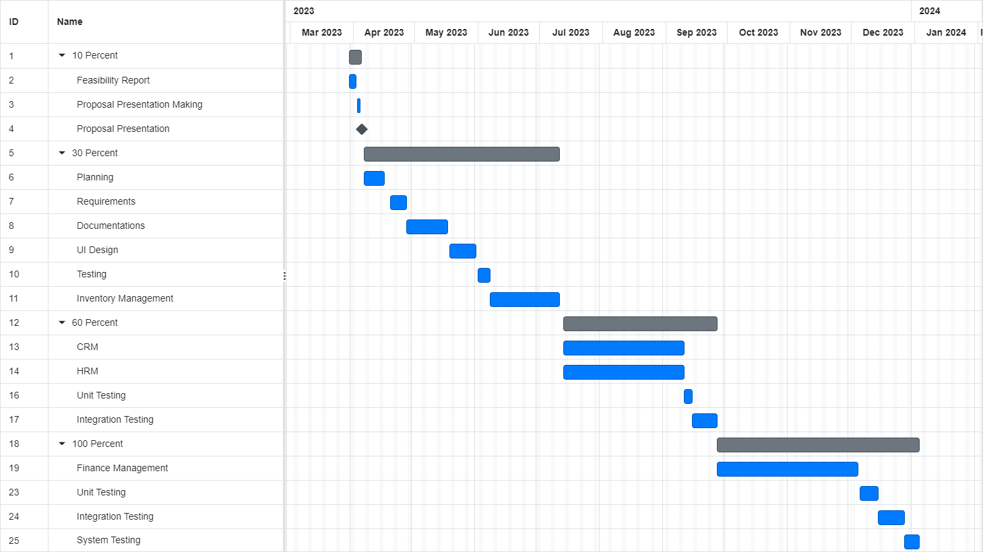

**References**

Kenge, R., & Khan, Z. I. (2020). A Research Study on the ERP System Implementation and Current Trends in ERP. *Shanlax International Journal of Management*, *8*(2), 34–39. <https://doi.org/10.34293/management.v8i2.3395>

*ERP implementation best practices | SAP*. (n.d.). SAP. <https://www.sap.com/mena/products/erp/what-is-erp/erp-implementation-best-practices.html>

Research, E. (2022, September 30). Essential ERP Implementation Best Practices. *ERP Implementation Best Practices*. <https://www.erpresearch.com/en-us/blog/erp-implementation-best-practices>

